**Topics: Descriptive Statistics and Probability**

1. Look at the data given below. Plot the data, find the outliers and find out $μ, σ, σ^{2}$

|  |  |
| --- | --- |
| **Name of company** | **Measure X** |
| Allied Signal | 24.23% |
| Bankers Trust | 25.53% |
| General Mills | 25.41% |
| ITT Industries | 24.14% |
| J.P.Morgan & Co. | 29.62% |
| Lehman Brothers | 28.25% |
| Marriott | 25.81% |
| MCI | 24.39% |
| Merrill Lynch | 40.26% |
| Microsoft | 32.95% |
| Morgan Stanley | 91.36% |
| Sun Microsystems | 25.99% |
| Travelers | 39.42% |
| US Airways | 26.71% |
| Warner-Lambert | 35.00% |

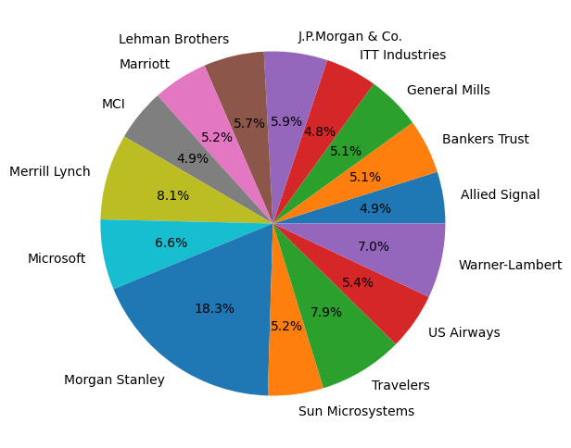

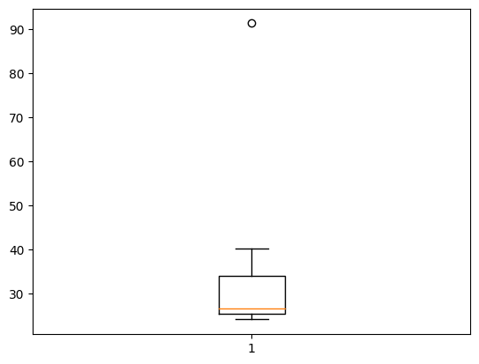

Only one outlier is present in the data as shown in the boxplot above at 91.

**Mean** = 33.27

**Standard Deviation** = 16.94

**Variance** = 287.14



Answer the following three questions based on the box-plot above.

1. What is inter-quartile range of this dataset? (please approximate the numbers) In one line, explain what this value implies.

**Ans**:

Q1= 12, Q3=5, Median = 7

IQR = 12-5 = 7. The Inter Quartile Range is equal to Median.

1. What can we say about the skewness of this dataset?

**Ans**: As the median is towards the other side, we can say that there is a right skew or positive skew present in the data

1. If it was found that the data point with the value 25 is actually 2.5, how would the new box-plot be affected?

**Ans**: If the point 25 was 2.5, the outlier will not be there and there will a less skewness available in the data as the outlier was majorly affecting it.



Answer the following three questions based on the histogram above.

1. Where would the mode of this dataset lie?

**Ans**: The mode of the data is approximately between the range of 4-8.

1. Comment on the skewness of the dataset.

**Ans**: The dataset is right skewed as there is a longer tail at the right-hand side of the histogram.

1. Suppose that the above histogram and the box-plot in question 2 are plotted for the same dataset. Explain how these graphs complement each other in providing information about any dataset.

**Ans**: Both the histogram and box plot are right skewed and both have outliers.

1. AT&T was running commercials in 1990 aimed at luring back customers who had switched to one of the other long-distance phone service providers. One such commercial shows a businessman trying to reach Phoenix and mistakenly getting Fiji, where a half-naked native on a beach responds incomprehensibly in Polynesian. When asked about this advertisement, AT&T admitted that the portrayed incident did not actually take place but added that this was an enactment of something that “could happen.” Suppose that one in 200 long-distance telephone calls is misdirected. What is the probability that at least one in five attempted telephone calls reaches the wrong number? (Assume independence of attempts.)

**Ans:**

1 in 200 telephone calls is misdirected

Probability of calls misdirecting = 1/200

Probability of calls not misdirecting = 199/200

n = 5

p = 1/200

q = 199/200

ⁿCₓ pˣ qⁿ⁻ˣ

= ⁵C₀(1/200)⁰(199/200)⁵⁻⁰

= (199/200)⁵

= 0.97918

= 1 - 0.97918

= 0.02475

Therefore, the probability that at least one in five attempted telephone calls reaches the wrong number is **0.02475**

1. Returns on a certain business venture, to the nearest $1,000, are known to follow the following probability distribution

|  |  |
| --- | --- |
| x | P(x) |
| -2,000 | 0.1 |
| -1,000 | 0.1 |
| 0 | 0.2 |
| 1000 | 0.2 |
| 2000 | 0.3 |
| 3000 | 0.1 |

**Ans:**

|  |  |  |  |
| --- | --- | --- | --- |
| X | P(X) | E(X)= X . P(X) | E(X²) = X² . P(X) |
| -2000 | 0.1 | -200 | 400000 |
| -1000 | 0.1 | -100 | 100000 |
| 0 | 0.2 | 0 | 0 |
| 1000 | 0.2 | 200 | 200000 |
| 2000 | 0.3 | 600 | 1200000 |
| 3000 | 0.1 | 300 | 900000 |
|  |  | **800** | **2800000** |

1. What is the most likely monetary outcome of the business venture?

**Ans**: The most likely monetary outcome would be $2000 as it has probability of 0.3 which is higher as compared to others.

1. Is the venture likely to be successful? Explain

**Ans**: Yes, the venture can be a successful one as the probability of generating profit adds 0.2 + 0.3 + 0.1 = 0.6 which means the venture has a chance of 60% of making profit.

1. What is the long-term average earning of business ventures of this kind? Explain

**Ans**: Long term average earning = (-200) + (-100) + 0 + 200 + 600 + 300 = 800 which is the average earning the venture will generate

1. What is the good measure of the risk involved in a venture of this kind? Compute this measure

**Ans**: The Variability in the data can show the risk involved in the venture. It can be analyzed by calculating the variance.

Variance = E(X²) - {E(X)} ²

= 2800000 – 800^2

= 2160000

The variance is quite high which means there might be a high risk involved in this venture.